# Analyzing a Market Test

## Plan My Analysis

I am a business analyst for Round Roasters, a coffee restaurant in US. The executive team conducted a market test with new menu and I need to use A/B testing to figure whether the new menu can drive enough sales to offset the cost of marketing the new menu and write up a recommendation.

From the data provided, I picked Store ID, Invoice Number, Invoice Date, Square feet, Average Month Sales, Gross Margin, Sales and Region to do my analysis. The performance metric is Gross_Margin. Test period is 12 weeks from 2016- April- 29 to 2016- July- 21. When I performed the data, I aggregated data at weekly basis.

## Clean Up Your Data

Please see below Alteryx workflow and the workflow file.

## 

## Match Treatment and Control Units

In this step, we need to match treatment and control units. The potential variables are Trend, Seasonality, Square feet, Avgmonthsales and Region. Since our performance metric is Gross

Margin, I pick only trend, seasonality, square feet and avgmonthsales to be further investigated. After I did the correlation analysis, it looks only AvgMonthSales has a high correlation with 0.99. So, for the final test, we only choose trend, seasonality and AveMonthSales as control variables.

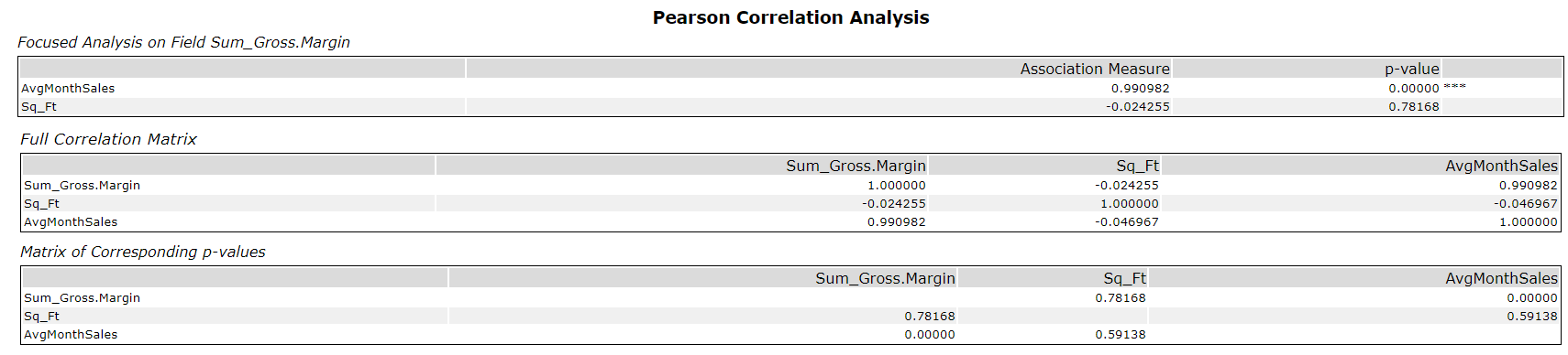

Please see below table for my treatment and control store pairs.

|  |  |  |
| --- | --- | --- |
| Treatment Store | Control Store 1 | Control Store 2 |
| 1664 | 12019 | 12586 |
| 1675 | 12786 | 3235 |
| 1696 | 3102 | 12286 |
| 1700 | 9968 | 2954 |
| 1712 | 10018 | 10468 |
| 2288 | 9081 | 1807 |
| 2293 | 12219 | 8362 |
| 2301 | 1964 | 1863 |
| 2322 | 7284 | 2409 |
| 2341 | 7162 | 12536 |

## Analysis and Writeup

West region result:

Average lift 37.9% with significance level 99.5%.

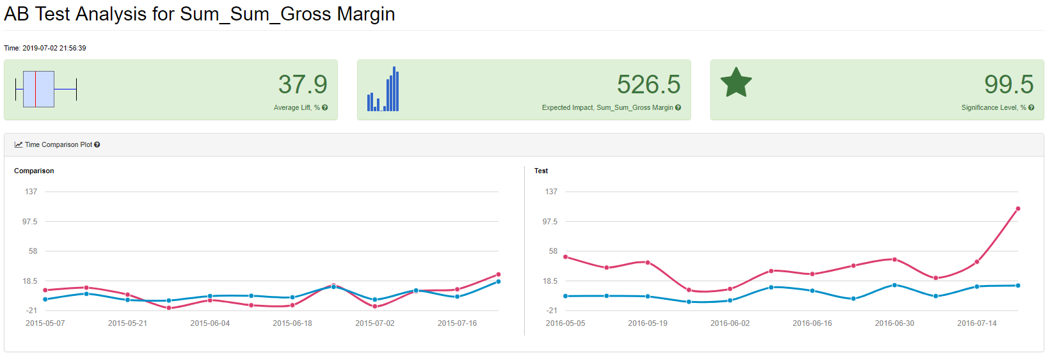

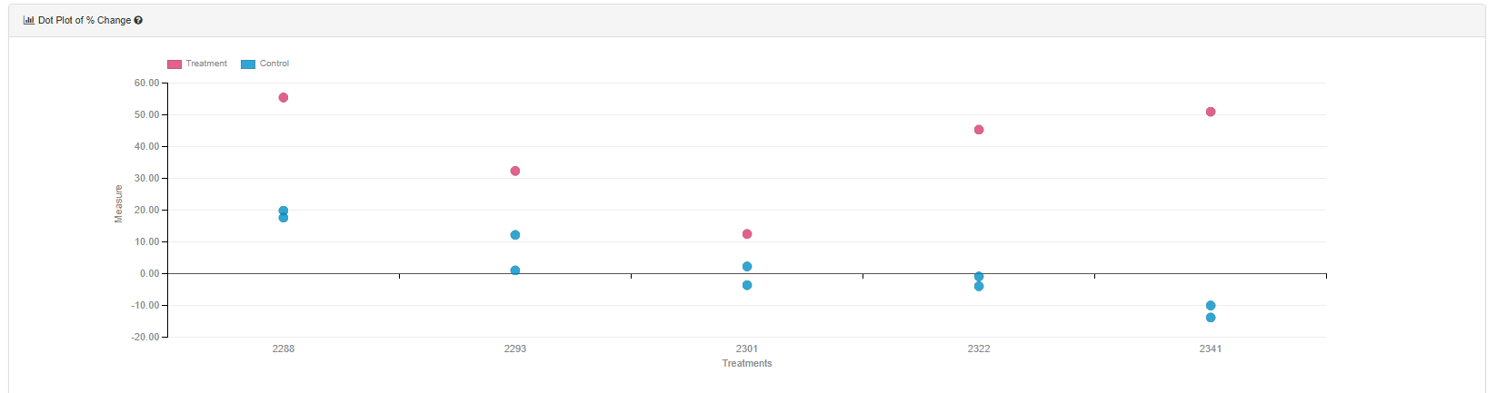

Central region result:

Average lift 43.5% with significance level 99.6%.

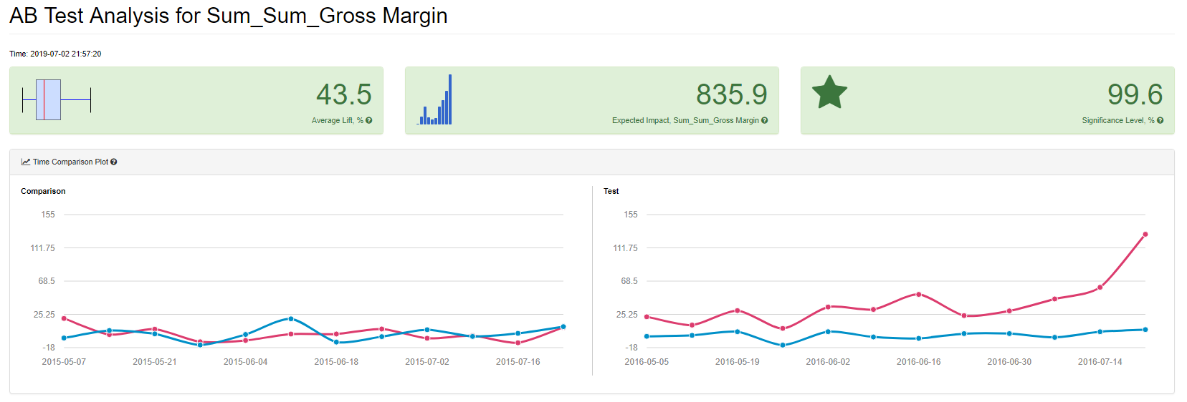

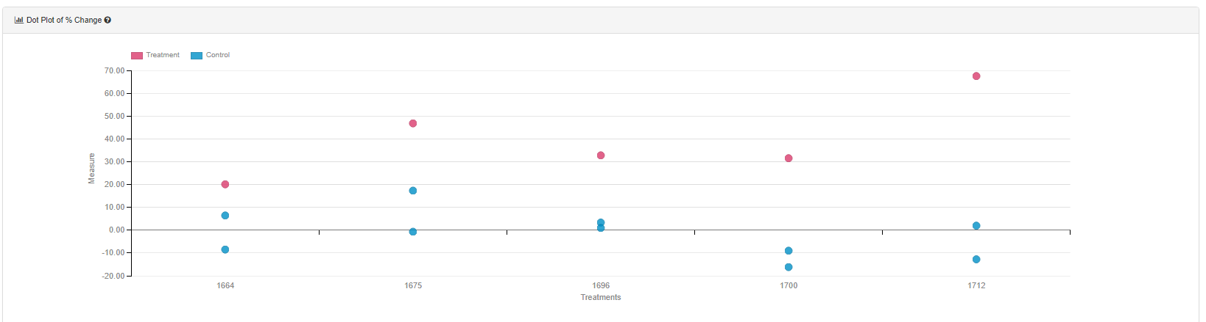

Overall result:

Average lift 39.7% with significance level 100%.

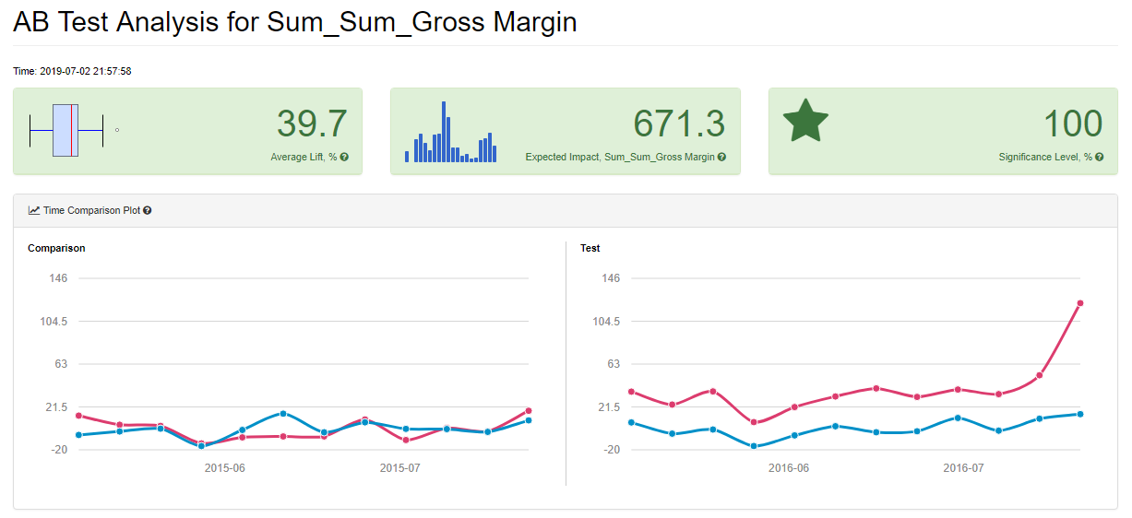

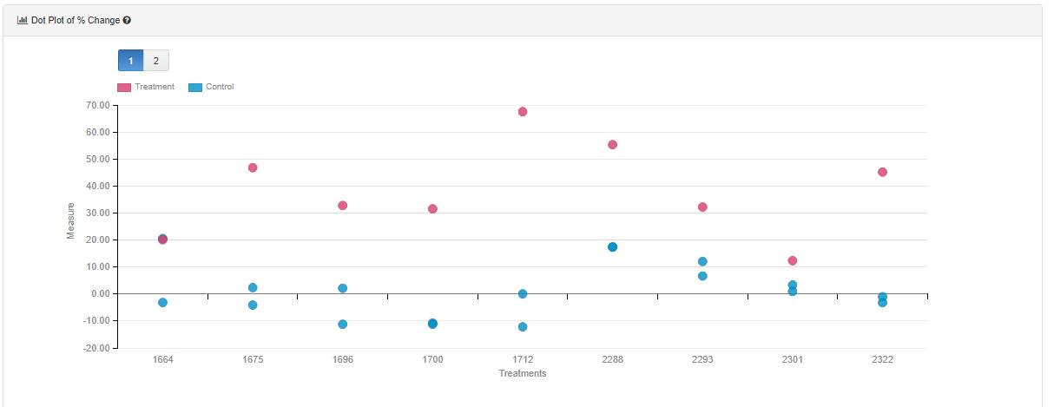

Please see above chart as A/B test analysis report.

I will recommend to update menu to all stores as the all 3 number for average lift is above 18% requirement to cover the ads cost.